编译原理 实验报告
实验名称 | 实验4 LR分析程序的设计与实现
姓名 | 杜佳俊 | 一卡通号 | 1520173711
专业班级 | 计算机中加171班 | 实验日期 | 6月10日
同组成员 |  | 得分

一、实验目的

1. 熟悉LR分析程序的设计与实现
2. 利用它进行语法分析，判断给出的符号串是否为该文法识别的句子
3. 了解LR（K）分析方法是严格的从左向右扫描
4. 掌握自底向上的语法分析方法。

二、实验内容
已知有下列文法G[S']
(0) S'→S
(1) S→aAd
(2) S→bAc
(3) S→aec
(4) S→bed
(5) A→e
1. 计算初始状态的LR(0)项目集
2. 计算每个状态的LR(0)项目集
3. 构造识别可归约前缀的DFA
4. 判断文法是否为SLR(1)文法
5. 如果不是SLR(1)文法，是否为LR(1)文法。
6. 构造LR(1)分析表
7. 编写文法的LR(1)分析程序，验证输入符号串是否符合语法。

三、实验设计
1. 计算初始状态的项目集
2. 计算每个状态的项目集
3. 构造识别可归约前缀的 DFA
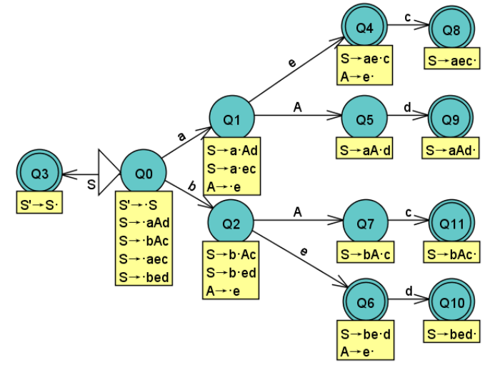
4. 判断文法是否为 SLR(1)文法
分析可知状态节点 Q4 和 Q6 中存在移进-归约冲突，不是 LR(0)文法。因为FOLLOW(A) = {c,d} ，{c}∩FOLLOW(A)≠Φ ，{d}∩FOLLOW(A)≠Φ,因此,也不是SLR(1)文法。
5. 判断文法是否为 LR(1)文法
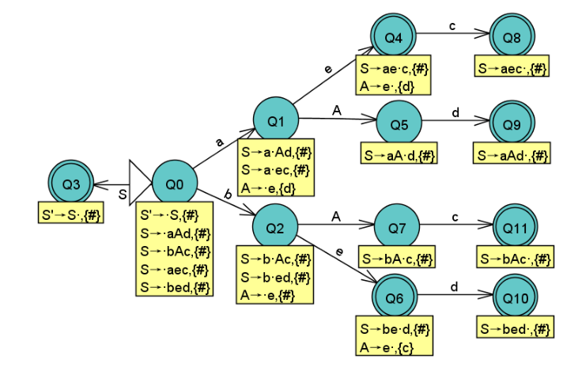
在状态节点 Q4 中，其移进项目的移进符号集合{c} 与规约项目的向前搜索集合{d} 交集为 Φ; 在状态节点 Q6 中，其移进项目的移进符号集合{d} 与规约项目的向前搜索集合{c} 交集为 Φ; 因此 ，文法是 LR(1)
6. 构造 LR(1)分析表
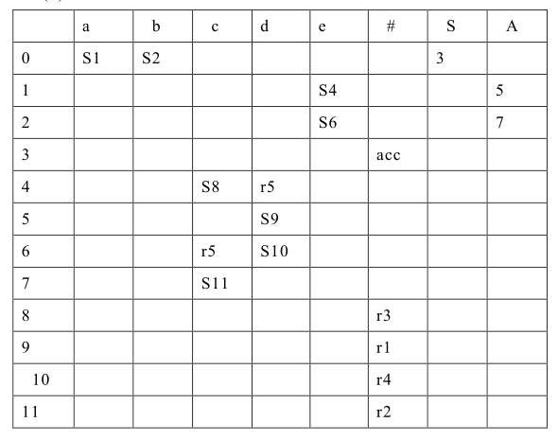

四、程序清单
#include<iostream>
#include<string>
#include<cstring>
#include<vector>
#include<ctype.h>
#include<stdlib.h>
using namespace std;
#define ROW 13
#define COLUMN 10
string Products[6][2]={
{"",""},
{"S","aAd"},
{"S","bAc"},
{"S","aec"},
{"S","bed"},
{"A","e"}
};
struct Action
{
string motion;
int n;
};
string ActionGotoTable[ROW][COLUMN]={
{"","a","b","c","d","e","#","S","A"},
{"0","S1","S2","","","","","3",""},
{"1","","","","","S4","","","5"},
{"2","","","","","S6","","","7"},
{"3","","","","","","acc","",""},
{"4","","","S8","r5","","","",""},
{"5","","","","S9","","","",""},
{"6","","","r5","S10","","","",""},
{"7","","","S11","","","","",""},
{"8","","","","","","r3","",""},
{"9","","","","","","r1","",""},
{"10","","","","","","r4","",""},
{"11","","","","","","r2","",""}
};
string GetProductLHS(int n)
{
return Products[n][0];
}
string GetProductRHS(int n)
{
return Products[n][1];
}
Action GetActionGoto(int status,string a)
{
int row = status + 1;
int column = -1;
Action action;
string str = "";
for(int i=0;i<COLUMN;i++){
if(a == ActionGotoTable[0][i])
{
column = i;
break;
}
}
if(row == -1 || column == -1)
str = "";
str = ActionGotoTable[row][column];
char num[10];
if(str.size() >= 1 && isdigit(str[0]))
{
strcpy(num,str.c_str());
action.motion="";
action.n=atoi(num);
}else if(str.size()>=1 && str[0] == 'S' || str[0] == 'r')
{
action.motion = str.substr(0,1);
strcpy(num,str.c_str()+1);
action.n = atoi(num);
}else if(str == "acc")
{
action.motion = "acc";
action.n = -1;
}else{
action.motion = "error";
action.n = -1;
}
return action;
}
bool LR0(string inputstring)
{
int i = 0;
bool flag = true;
int currentstatus = 0;
string LHS,RHS,a;
Action action;
vector<string> SymbolStack;
vector<int> StatusStack;
StatusStack.push_back(currentstatus);
SymbolStack.push_back("#");
a = inputstring[i];
while(true)
{
action = GetActionGoto(currentstatus,a);
if(action.motion == "S")
{
currentstatus = action.n;
StatusStack.push_back(currentstatus);
SymbolStack.push_back(a);
a = inputstring[++i];
}else if(action.motion == "r")
{
int n = action.n;
LHS = GetProductLHS(n);
RHS = GetProductRHS(n);
int size = RHS.size();
for(int i=0;i<size;i++)
{
StatusStack.pop_back();
SymbolStack.pop_back();
}
SymbolStack.push_back(LHS);
currentstatus = StatusStack[StatusStack.size()-1];
action = GetActionGoto(currentstatus,LHS);
currentstatus = action.n;
StatusStack.push_back(currentstatus);
}else if(action.motion == "acc")
{
flag = true;
break;
}else
{
flag = false;
break;
}
}
return flag;
}
int main()
{
string symbolstring;
while(cin>>symbolstring)
{
bool flag = LR0(symbolstring);
if(flag)
cout<<"syntax correct"<<endl;
else
cout<<"syntax error"<<endl;
}
return 0;
}

五、结果分析
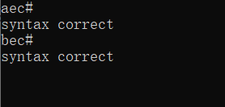

六、实验总结
通过实验，我掌握了自底向上的语法分析方法，了解了LR（K）分析方法是严格的从左向右扫描。并利用它进行语法分析，判断给出的符号串是否为该文法识别的句子。

